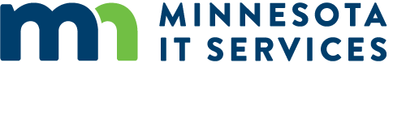

Resources

Cynefin Framework
- Cognitive Edge - https://cognitive-edge.com/videos/cynefin-framework-introduction/

Change Management
- Transitions Theory - Bridges, W., & Bridges, S. (2017). Managing Transitions, 25th anniversary edition: Making the Most of Change. Boulder: Da Capo Press.
- Summary guide - https://www.mindtools.com/pages/article/bridges-transition-model.htm

Logic Models
- Logic Model Guide from the University of Minnesota - https://cyfar.org/what-logic-model

Human Centered Design
- Design Kit from ideo.org - https://www.designkit.org/
- MMB Skills Development Courses - https://mn.gov/mmb/etd/skills-development-courses/open-enrollment-courses/

Collaboration and participatory processes
- Chaordic Stepping Stones - http://www.chriscorrigan.com/parkinglot/how/
- Art of Hosting and Harvesting conversations that matter - http://www.artofhosting.org/
- Liberating Structures - http://www.liberatingstructures.com/

