As an attendee for the 2021 Transforming Learning Summit, August 11 + 12th, we invite you to use the following sample social posts and graphics to help promote the event to our audience. You are welcome to come up with your own as well! Don’t forget to use tags. If you have any questions or would like anything additional, please reach out to us @ marketing@fusionlp.org.
- Register now https://fusionlp.regfox.com/2021tls-attendees and join me August 11-12 at the 2021 #TLSummit
- Excited for the 2021 #TLSummit. Don't miss out, register now: https://fusionlp.regfox.com/2021tls-attendees
- Find strategies and inspiration to re-engage your passion for education at the 2021 #TLSummit.
- Engage in courageous conversations around diversity, equity and inclusion at the 2021 #TLSummit.
I WILL BE ATTENDING GRAPHIC:

GENERAL GRAPHIC:
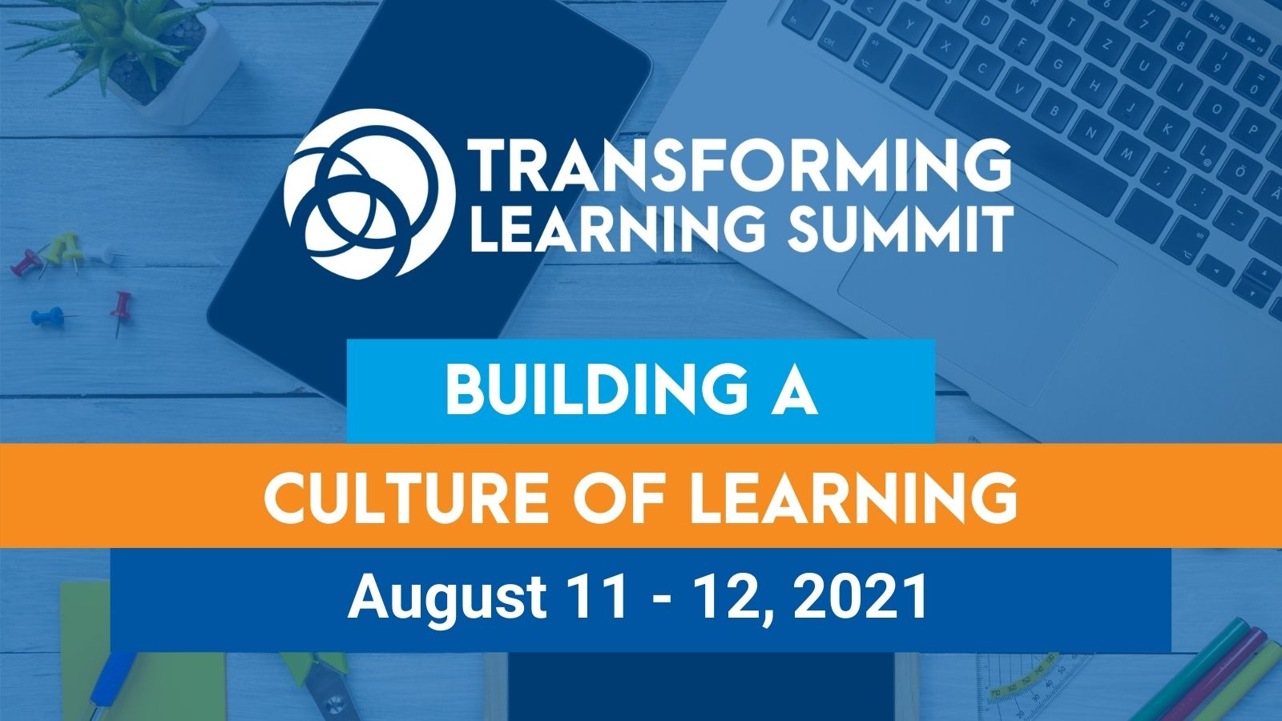
SIX PATHWAYS GRAPHIC:
