As a sponsor of the 2021 Government IT Symposium, we invite you to use the following sample social posts and graphics to help promote the event to our audience. You are welcome to come up with your own as well! Don’t forget to tag us @MnITsymp and use #GovITSym. If you have any questions or would like anything additional, please reach out to us @ marketing@fusionlp.org.
- Register now https://bit.ly/3CLutsC and join me November 15-18th at the 2021 #GovITSym
- Excited for the 2021 #GovITSym November 15 – 18th. Don't miss out, register now: https://bit.ly/3CLutsC
- I / We proudly support the 2021 #GovITSym as a Sponsor. Don't miss it! https://bit.ly/3CLutsC
- Join me at the 2021 #GovITSym for engaging and innovative content that is bound to help you discover new strategies and tactics that Elevate Your Game! https://bit.ly/3CLutsC
SPONSOR GRAPHIC:
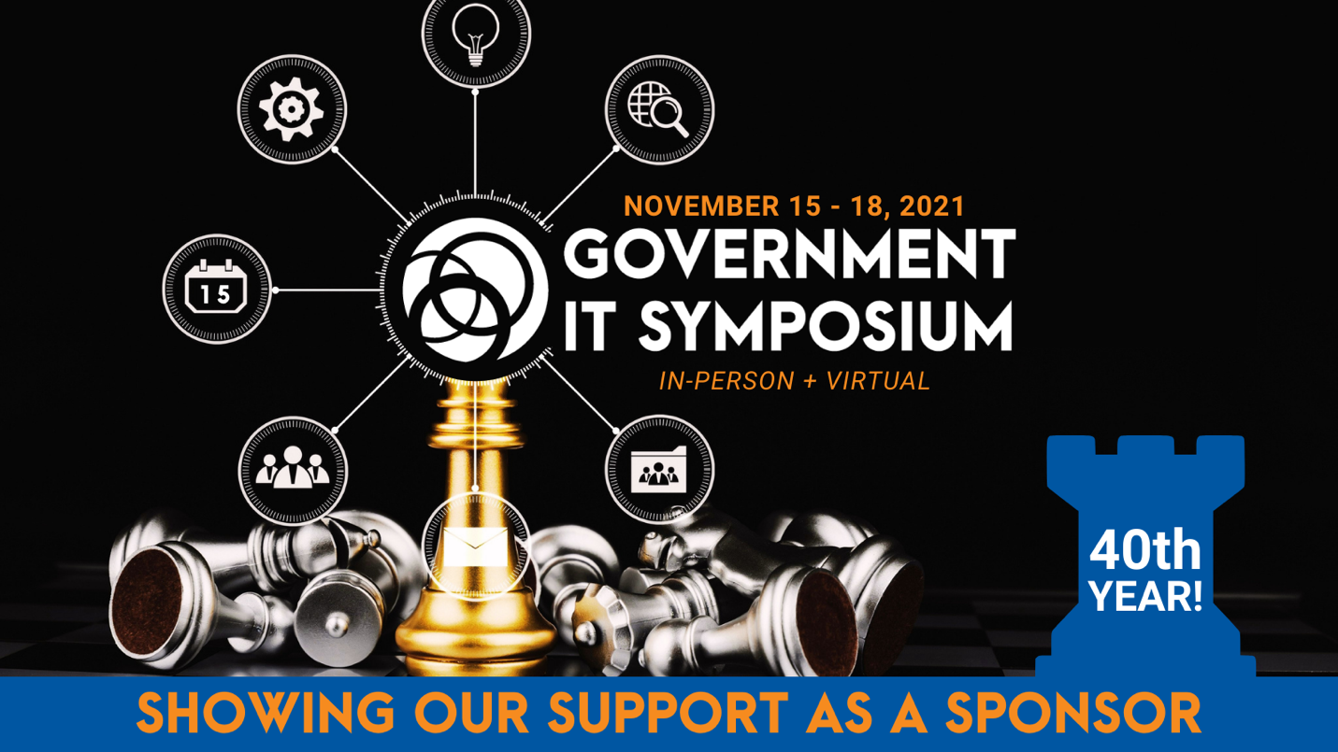

KEYNOTES GRAPHIC:
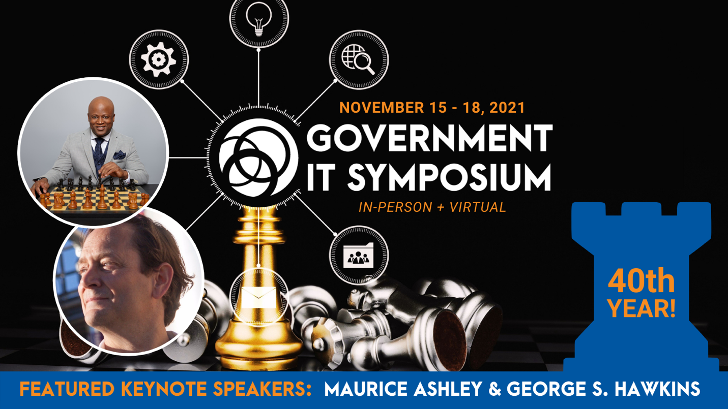
PRESENTING GRAPHIC:
